MGMS – Expenses

Detailed Design Document

Ver. 1.4

Version History
Date | Description
23-Oct-2010 | First draft

Table of Contents

Version History 2
1 Introduction 4
2 Expenses 4
2.1 Record Expenses 4
2.2 View expenses for a period 6
2.3 View expenses head wise 7
3 Associated Tables 7
4 Data Dictionary 8

Introduction

This document provides the detailed design specifications for the Multisite Grant Management System project.

This is not a project plan nor does it detail the source code. It is a guide for system architecture and development, not for phasing, timelines or deliverables.

Finally, this is a ‘living document’ and the specification will change, continuously, as the project proceeds. More details will be added and the existing information edited as the requirements, architecture and design evolve in the course of the project.

Expenses

Record Expenses

Each project in an institution incurs expenses in the nature of – salaries, materials and assets purchase etc. The expenses are categorized into account heads, for e.g., manpower, material purchase, finance etc
These are recorded here against the specific grant allocation which is expected to pay for the expenses.
For each project, it is required to view list of individual expenses as well as summarized account head wise. expense for a period.

This expense DOES NOT include any funds transferred to grantee institutions of the user institution.

Screen & Control Description

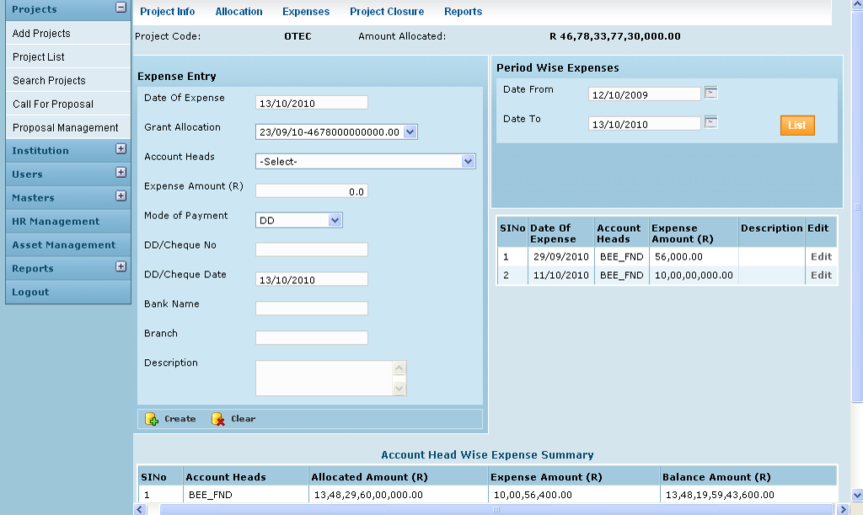

Field /Label | Input-Control | Data Type | Remarks / db table>field
Project Code: | Auto populated | varchar(255) | projects>code
Amount Allocated | Auto populated | double | grant_allocation>amount_allocated
Expense Entry
Date of Expense | Calendar ? | datetime | grant_expense>date_of_expense
Grant Allocation: | Listbox | varchar(255) | grant_allocation>date_of_allocation -grant_allocation>amount_allocated
Expense Amount (R) | Textbox | double | grant_expense>expense_amount
Account Heads | Listbox | varchar(255) | account_heads>name
Mode of Payment | Textbox | varchar(255) | grant_expense>mode_of_payment
DD/Cheque No: | Textbox | varchar(255) | grant_expense>dd_no
DD/Cheque Date | Textbox | datetime | grant_expense>dd_date
Bank Name | Calendar | varchar(255) | grant_expense>bank_name
Branch | Textbox | varchar(255) | grant_expense>dd_branch
Description | Textbox | varchar(255) | grant_expense>description
Create | Button |  | Entries saved
Clear | Button

View expenses for a period
Screen & Control Description

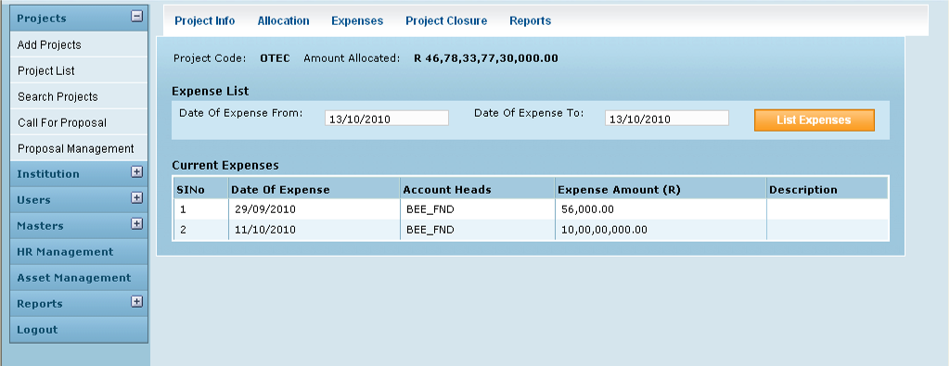

Field /Label | Input-Control | Data Type | Remarks / db table>field
Project Code: | Auto populated | varchar(255) | projects>code
Amount Allocated: | Auto populated | double | grant_allocation>amount_allocated
Expense List
Date of Expense from: | Calendar | Datetime | User Input –search criteria
Date of Expense to: | Calendar | Datetime | User Input –search criteria
List Expenses | Button |  | On clicking , gives the list of expenses and details
Current Expenses
Sl No | Auto increment populated
Date of Expense | Auto populated | Datetime | grant_expense>date_of_expense
Account Heads | Auto populated | varchar(255) | account_heads>code
Expense Amount (R) | Auto populated | double | grant_expense>expense_amount
Description | Auto populated | varchar(255) | grant_expense>description

View expenses head wise

Screen & Control Description

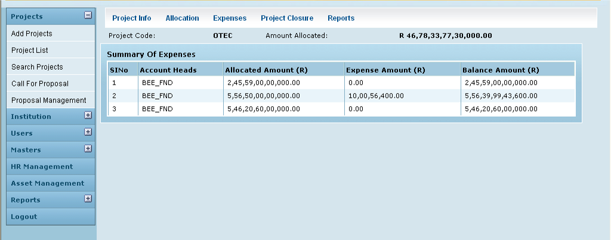

Field /Label | Input-Control | Data Type | Remarks / db table>field
Project Code: | Auto populated | varchar(255) | projects>code
Amount Allocated: | Auto populated | double | grant_allocation>amount_allocated
Summary of Expenses
Sl No | Auto populated
Account Heads | Auto populated | varchar(255) | account_heads>code
Allocated Amount (R) | Auto populated | calculated | sum of all values of grant_allocation>amount_allocated
Expense Amount (R) | Auto populated | calculated | sum of all values of grant_expense>expense_amount
Balance Amount (R) | Auto populated | calculated | Allocated Amount - Expense Amount

Associated Tables

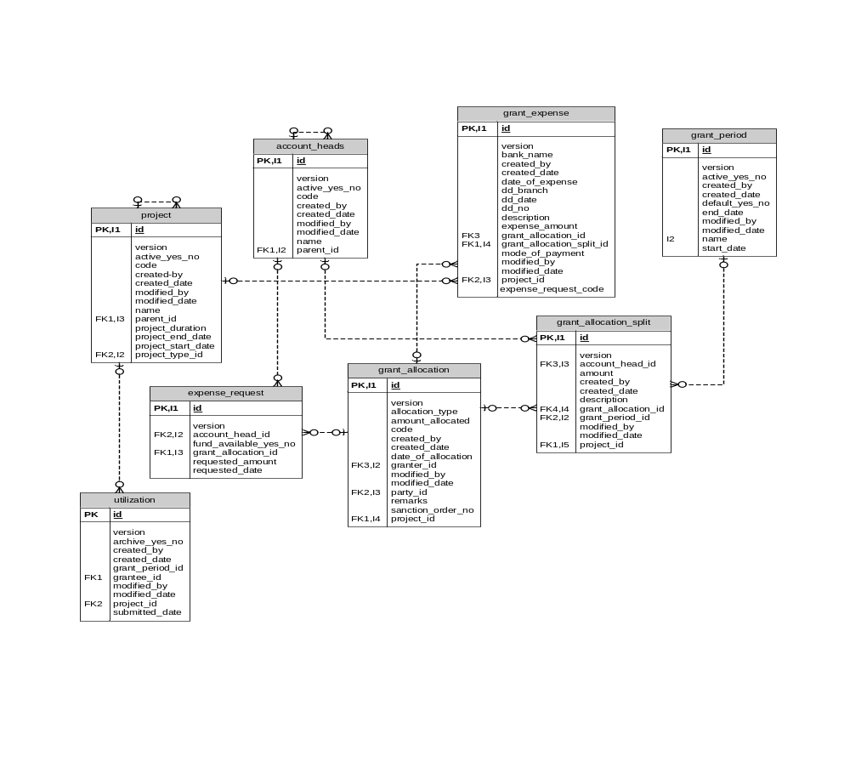

Data Dictionary

account_heads

Fields

Field | Type | Collation | Null | Key | Default | Extra | Privileges
id | bigint(20) | (NULL) | NO | PRI | (NULL) | auto_increment | select,insert,update,references
version | bigint(20) | (NULL) | NO |  |  |  | select,insert,update,references
active_yes_no | char(1) | latin1_swedish_ci | NO |  |  |  | select,insert,update,references
code | varchar(255) | latin1_swedish_ci | NO |  |  |  | select,insert,update,references
created_by | varchar(255) | latin1_swedish_ci | NO |  |  |  | select,insert,update,references
created_date | datetime | (NULL) | YES |  | (NULL) |  | select,insert,update,references
modified_by | varchar(255) | latin1_swedish_ci | NO |  |  |  | select,insert,update,references
modified_date | datetime | (NULL) | YES |  | (NULL) |  | select,insert,update,references
name | varchar(255) | latin1_swedish_ci | NO |  |  |  | select,insert,update,references
parent_id | bigint(20) | (NULL) | YES | MUL | (NULL) |  | select,insert,update,references

Indexes

Table | Non  unique | Key  name | Seq  in  index | Column  name | Collation | Cardinality | Sub  part | Packed | Null | Index  type
account_heads | 0 | PRIMARY | 1 | id | A | 102 | (NULL) | (NULL) |  | BTREE
account_heads | 1 | FKE001C601C4F4CD56 | 1 | parent_id | A | 51 | (NULL) | (NULL) | YES | BTREE

Foreign Key Relationships

FK Id | Reference Table | Source Column | Target Column | Extra Info
FKE001C601C4F4CD56 | account_heads | `parent_id` | `id`
expense_request

Fields

Field | Type | Collation | Null | Key | Default | Extra | Privileges
id | bigint(20) | (NULL) | NO | PRI | (NULL) | auto_increment | select,insert,update,references
version | bigint(20) | (NULL) | NO |  |  |  | select,insert,update,references
account_head_id | bigint(20) | (NULL) | NO | MUL |  |  | select,insert,update,references
fund_available_yes_no | char(1) | latin1_swedish_ci | NO |  |  |  | select,insert,update,references
grant_allocation_id | bigint(20) | (NULL) | NO | MUL |  |  | select,insert,update,references
requested_amount | double | (NULL) | NO |  |  |  | select,insert,update,references
requested_date | datetime | (NULL) | NO |  |  |  | select,insert,update,references

Indexes

Table | Non  unique | Key  name | Seq  in  index | Column  name | Collation | Cardinality | Sub  part | Packed | Null | Index  type
expense_request | 0 | PRIMARY | 1 | id | A | 0 | (NULL) | (NULL) |  | BTREE
expense_request | 1 | FKBA1189A83036284E | 1 | account_head_id | A | 0 | (NULL) | (NULL) |  | BTREE
expense_request | 1 | FKBA1189A8B8D959F3 | 1 | grant_allocation_id | A | 0 | (NULL) | (NULL) |  | BTREE

Foreign Key Relationships

FK Id | Reference Table | Source Column | Target Column | Extra Info
FKBA1189A8B8D959F3 | grant_allocation | `grant_allocation_id` | `id` | ,
FKBA1189A83036284E | account_heads | `account_head_id` | `id`

grant_allocation

Fields

Field | Type | Collation | Null | Key | Default | Extra | Privileges
id | bigint(20) | (NULL) | NO | PRI | (NULL) | auto_increment | select,insert,update,references
version | bigint(20) | (NULL) | NO |  |  |  | select,insert,update,references
allocation_type | varchar(255) | latin1_swedish_ci | NO |  |  |  | select,insert,update,references
amount_allocated | double | (NULL) | NO |  |  |  | select,insert,update,references
code | varchar(255) | latin1_swedish_ci | NO |  |  |  | select,insert,update,references
created_by | varchar(255) | latin1_swedish_ci | NO |  |  |  | select,insert,update,references
created_date | datetime | (NULL) | YES |  | (NULL) |  | select,insert,update,references
date_of_allocation | datetime | (NULL) | NO |  |  |  | select,insert,update,references
granter_id | bigint(20) | (NULL) | YES | MUL | (NULL) |  | select,insert,update,references
modified_by | varchar(255) | latin1_swedish_ci | NO |  |  |  | select,insert,update,references
modified_date | datetime | (NULL) | YES |  | (NULL) |  | select,insert,update,references
party_id | bigint(20) | (NULL) | NO | MUL |  |  | select,insert,update,references
projects_id | bigint(20) | (NULL) | NO | MUL |  |  | select,insert,update,references
remarks | varchar(255) | latin1_swedish_ci | NO |  |  |  | select,insert,update,references
sanction_order_no | varchar(255) | latin1_swedish_ci | YES |  | (NULL) |  | select,insert,update,references

Indexes

Table | Non  unique | Key  name | Seq  in  index | Column  name | Collation | Cardinality | Sub  part | Packed | Null | Index  type
grant_allocation | 0 | PRIMARY | 1 | id | A | 457 | (NULL) | (NULL) |  | BTREE
grant_allocation | 1 | FK221B5BE337914517 | 1 | granter_id | A | 45 | (NULL) | (NULL) | YES | BTREE
grant_allocation | 1 | FK221B5BE34B78CFDA | 1 | party_id | A | 76 | (NULL) | (NULL) |  | BTREE
grant_allocation | 1 | FK221B5BE3905C4B9A | 1 | projects_id | A | 457 | (NULL) | (NULL) |  | BTREE

Foreign Key Relationships

FK Id | Reference Table | Source Column | Target Column | Extra Info
FK221B5BE3905C4B9A | projects | `projects_id` | `id` | ,
FK221B5BE337914517 | party | `granter_id` | `id` | ,
FK221B5BE34B78CFDA | party | `party_id` | `id`
grant_allocation_split

Fields

Field | Type | Collation | Null | Key | Default | Extra | Privileges
id | bigint(20) | (NULL) | NO | PRI | (NULL) | auto_increment | select,insert,update,references
version | bigint(20) | (NULL) | NO |  |  |  | select,insert,update,references
account_head_id | bigint(20) | (NULL) | NO | MUL |  |  | select,insert,update,references
amount | double | (NULL) | NO |  |  |  | select,insert,update,references
created_by | varchar(255) | latin1_swedish_ci | NO |  |  |  | select,insert,update,references
created_date | datetime | (NULL) | NO |  |  |  | select,insert,update,references
description | varchar(255) | latin1_swedish_ci | NO |  |  |  | select,insert,update,references
grant_allocation_id | bigint(20) | (NULL) | YES | MUL | (NULL) |  | select,insert,update,references
grant_period_id | bigint(20) | (NULL) | NO | MUL |  |  | select,insert,update,references
modified_by | varchar(255) | latin1_swedish_ci | YES |  | (NULL) |  | select,insert,update,references
modified_date | datetime | (NULL) | YES |  | (NULL) |  | select,insert,update,references
projects_id | bigint(20) | (NULL) | NO | MUL |  |  | select,insert,update,references

Indexes

Table | Non  unique | Key  name | Seq  in  index | Column  name | Collation | Cardinality | Sub  part | Packed | Null | Index  type
grant_allocation_split | 0 | PRIMARY | 1 | id | A | 147 | (NULL) | (NULL) |  | BTREE
grant_allocation_split | 1 | FK49B723BE161A26D3 | 1 | grant_period_id | A | 12 | (NULL) | (NULL) |  | BTREE
grant_allocation_split | 1 | FK49B723BE3036284E | 1 | account_head_id | A | 73 | (NULL) | (NULL) |  | BTREE
grant_allocation_split | 1 | FK49B723BEB8D959F3 | 1 | grant_allocation_id | A | 147 | (NULL) | (NULL) | YES | BTREE
grant_allocation_split | 1 | FK49B723BE905C4B9A | 1 | projects_id | A | 147 | (NULL) | (NULL) |  | BTREE

Foreign Key Relationships

FK Id | Reference Table | Source Column | Target Column | Extra Info
FK49B723BE905C4B9A | projects | `projects_id` | `id` | ,
FK49B723BE161A26D3 | grant_period | `grant_period_id` | `id` | ,
FK49B723BE3036284E | account_heads | `account_head_id` | `id` | ,
FK49B723BEB8D959F3 | grant_allocation | `grant_allocation_id` | `id`
grant_expense

Fields

Field | Type | Collation | Null | Key | Default | Extra | Privileges
id | bigint(20) | (NULL) | NO | PRI | (NULL) | auto_increment | select,insert,update,references
version | bigint(20) | (NULL) | NO |  |  |  | select,insert,update,references
bank_name | varchar(255) | latin1_swedish_ci | NO |  |  |  | select,insert,update,references
created_by | varchar(255) | latin1_swedish_ci | NO |  |  |  | select,insert,update,references
created_date | datetime | (NULL) | NO |  |  |  | select,insert,update,references
date_of_expense | datetime | (NULL) | NO |  |  |  | select,insert,update,references
dd_branch | varchar(255) | latin1_swedish_ci | NO |  |  |  | select,insert,update,references
dd_date | datetime | (NULL) | NO |  |  |  | select,insert,update,references
dd_no | varchar(255) | latin1_swedish_ci | NO |  |  |  | select,insert,update,references
description | varchar(255) | latin1_swedish_ci | NO |  |  |  | select,insert,update,references
expense_amount | double | (NULL) | NO |  |  |  | select,insert,update,references
grant_allocation_id | bigint(20) | (NULL) | YES | MUL | (NULL) |  | select,insert,update,references
grant_allocation_split_id | bigint(20) | (NULL) | YES | MUL | (NULL) |  | select,insert,update,references
mode_of_payment | varchar(255) | latin1_swedish_ci | NO |  |  |  | select,insert,update,references
modified_by | varchar(255) | latin1_swedish_ci | YES |  | (NULL) |  | select,insert,update,references
modified_date | datetime | (NULL) | YES |  | (NULL) |  | select,insert,update,references
projects_id | bigint(20) | (NULL) | NO | MUL |  |  | select,insert,update,references
expense_request_code | varchar(255) | latin1_swedish_ci | YES |  | (NULL) |  | select,insert,update,references

Indexes

Table | Non  unique | Key  name | Seq  in  index | Column  name | Collation | Cardinality | Sub  part | Packed | Null | Index  type
grant_expense | 0 | PRIMARY | 1 | id | A | 88 | (NULL) | (NULL) |  | BTREE
grant_expense | 1 | FK33905435B8D959F3 | 1 | grant_allocation_id | A | 88 | (NULL) | (NULL) | YES | BTREE
grant_expense | 1 | FK33905435905C4B9A | 1 | projects_id | A | 88 | (NULL) | (NULL) |  | BTREE
grant_expense | 1 | FK3390543533CE82BA | 1 | grant_allocation_split_id | A | 88 | (NULL) | (NULL) | YES | BTREE

Foreign Key Relationships

FK Id | Reference Table | Source Column | Target Column | Extra Info
FK3390543533CE82BA | grant_allocation_split | `grant_allocation_split_id` | `id` | ,
FK33905435905C4B9A | projects | `projects_id` | `id` | ,
FK33905435B8D959F3 | grant_allocation | `grant_allocation_id` | `id`

grant_period

Fields

Field | Type | Collation | Null | Key | Default | Extra | Privileges
id | bigint(20) | (NULL) | NO | PRI | (NULL) | auto_increment | select,insert,update,references
version | bigint(20) | (NULL) | NO |  |  |  | select,insert,update,references
active_yes_no | char(1) | latin1_swedish_ci | NO |  |  |  | select,insert,update,references
created_by | varchar(255) | latin1_swedish_ci | NO |  |  |  | select,insert,update,references
created_date | datetime | (NULL) | YES |  | (NULL) |  | select,insert,update,references
default_yes_no | char(1) | latin1_swedish_ci | NO |  |  |  | select,insert,update,references
end_date | datetime | (NULL) | NO |  |  |  | select,insert,update,references
modified_by | varchar(255) | latin1_swedish_ci | NO |  |  |  | select,insert,update,references
modified_date | datetime | (NULL) | YES |  | (NULL) |  | select,insert,update,references
name | varchar(255) | latin1_swedish_ci | NO | MUL |  |  | select,insert,update,references
start_date | datetime | (NULL) | NO |  |  |  | select,insert,update,references

Indexes

Table | Non  unique | Key  name | Seq  in  index | Column  name | Collation | Cardinality | Sub  part | Packed | Null | Index  type
grant_period | 0 | PRIMARY | 1 | id | A | 76 | (NULL) | (NULL) |  | BTREE
grant_period | 1 | name | 1 | name | A | 76 | (NULL) | (NULL) |  | BTREE
investigator

Fields

Field | Type | Collation | Null | Key | Default | Extra | Privileges
id | bigint(20) | (NULL) | NO | PRI | (NULL) | auto_increment | select,insert,update,references
version | bigint(20) | (NULL) | NO |  |  |  | select,insert,update,references
active_yes_no | char(1) | latin1_swedish_ci | NO |  |  |  | select,insert,update,references
address | varchar(255) | latin1_swedish_ci | NO |  |  |  | select,insert,update,references
department_id | bigint(20) | (NULL) | YES | MUL | (NULL) |  | select,insert,update,references
designation | varchar(255) | latin1_swedish_ci | NO |  |  |  | select,insert,update,references
email | varchar(255) | latin1_swedish_ci | NO | UNI |  |  | select,insert,update,references
name | varchar(255) | latin1_swedish_ci | NO | MUL |  |  | select,insert,update,references
party_id | bigint(20) | (NULL) | NO | MUL |  |  | select,insert,update,references

Indexes

Table | Non  unique | Key  name | Seq  in  index | Column  name | Collation | Cardinality | Sub  part | Packed | Null | Index  type
investigator | 0 | PRIMARY | 1 | id | A | 84 | (NULL) | (NULL) |  | BTREE
investigator | 0 | email | 1 | email | A | 84 | (NULL) | (NULL) |  | BTREE
investigator | 1 | FK967BBBA99F389FE0 | 1 | department_id | A | 84 | (NULL) | (NULL) | YES | BTREE
investigator | 1 | FK967BBBA94B78CFDA | 1 | party_id | A | 28 | (NULL) | (NULL) |  | BTREE
investigator | 1 | name | 1 | name | A | 84 | (NULL) | (NULL) |  | BTREE

Foreign Key Relationships

FK Id | Reference Table | Source Column | Target Column | Extra Info
FK967BBBA94B78CFDA | party | `party_id` | `id` | ,
FK967BBBA99F389FE0 | party_department | `department_id` | `id`
projects

Fields

Field | Type | Collation | Null | Key | Default | Extra | Privileges
id | bigint(20) | (NULL) | NO | PRI | (NULL) | auto_increment | select,insert,update,references
version | bigint(20) | (NULL) | NO |  |  |  | select,insert,update,references
active_yes_no | char(1) | latin1_swedish_ci | NO |  |  |  | select,insert,update,references
code | varchar(255) | latin1_swedish_ci | NO |  |  |  | select,insert,update,references
created_by | varchar(255) | latin1_swedish_ci | NO |  |  |  | select,insert,update,references
created_date | datetime | (NULL) | NO |  |  |  | select,insert,update,references
modified_by | varchar(255) | latin1_swedish_ci | NO |  |  |  | select,insert,update,references
modified_date | datetime | (NULL) | NO |  |  |  | select,insert,update,references
name | varchar(255) | latin1_swedish_ci | NO |  |  |  | select,insert,update,references
parent_id | bigint(20) | (NULL) | YES | MUL | (NULL) |  | select,insert,update,references
project_duration | varchar(255) | latin1_swedish_ci | YES |  | (NULL) |  | select,insert,update,references
project_end_date | datetime | (NULL) | YES |  | (NULL) |  | select,insert,update,references
project_start_date | datetime | (NULL) | YES |  | (NULL) |  | select,insert,update,references
project_type_id | int(11) | (NULL) | NO | MUL |  |  | select,insert,update,references

Indexes

Table | Non  unique | Key  name | Seq  in  index | Column  name | Collation | Cardinality | Sub  part | Packed | Null | Index  type
projects | 0 | PRIMARY | 1 | id | A | 229 | (NULL) | (NULL) |  | BTREE
projects | 1 | FKC479187A69DF6AED | 1 | project_type_id | A | 229 | (NULL) | (NULL) |  | BTREE
projects | 1 | FKC479187A43BA2D6A | 1 | parent_id | A | 229 | (NULL) | (NULL) | YES | BTREE

Foreign Key Relationships

FK Id | Reference Table | Source Column | Target Column | Extra Info
FKC479187A43BA2D6A | projects | `parent_id` | `id` | ,
FKC479187A69DF6AED | project_type | `project_type_id` | `id`
utilization

Fields

Field | Type | Collation | Null | Key | Default | Extra | Privileges
id | bigint(20) | (NULL) | NO | PRI | (NULL) | auto_increment | select,insert,update,references
version | bigint(20) | (NULL) | NO |  |  |  | select,insert,update,references
archive_yes_no | varchar(255) | latin1_swedish_ci | YES |  | (NULL) |  | select,insert,update,references
created_by | varchar(255) | latin1_swedish_ci | YES |  | (NULL) |  | select,insert,update,references
created_date | datetime | (NULL) | YES |  | (NULL) |  | select,insert,update,references
end_date | datetime | (NULL) | NO |  |  |  | select,insert,update,references
grantee_id | bigint(20) | (NULL) | NO | MUL |  |  | select,insert,update,references
modified_by | varchar(255) | latin1_swedish_ci | YES |  | (NULL) |  | select,insert,update,references
modified_date | datetime | (NULL) | YES |  | (NULL) |  | select,insert,update,references
projects_id | bigint(20) | (NULL) | NO | MUL |  |  | select,insert,update,references
start_date | datetime | (NULL) | NO |  |  |  | select,insert,update,references
submitted_date | datetime | (NULL) | NO |  |  |  | select,insert,update,references

Indexes

Table | Non  unique | Key  name | Seq  in  index | Column  name | Collation | Cardinality | Sub  part | Packed | Null | Index  type
utilization | 0 | PRIMARY | 1 | id | A | 51 | (NULL) | (NULL) |  | BTREE
utilization | 1 | FKE9082E22378B5C44 | 1 | grantee_id | A | 17 | (NULL) | (NULL) |  | BTREE
utilization | 1 | FKE9082E22905C4B9A | 1 | projects_id | A | 51 | (NULL) | (NULL) |  | BTREE

Foreign Key Relationships

FK Id | Reference Table | Source Column | Target Column | Extra Info
FKE9082E22905C4B9A | projects | `projects_id` | `id` | ,
FKE9082E22378B5C44 | party | `grantee_id` | `id`

